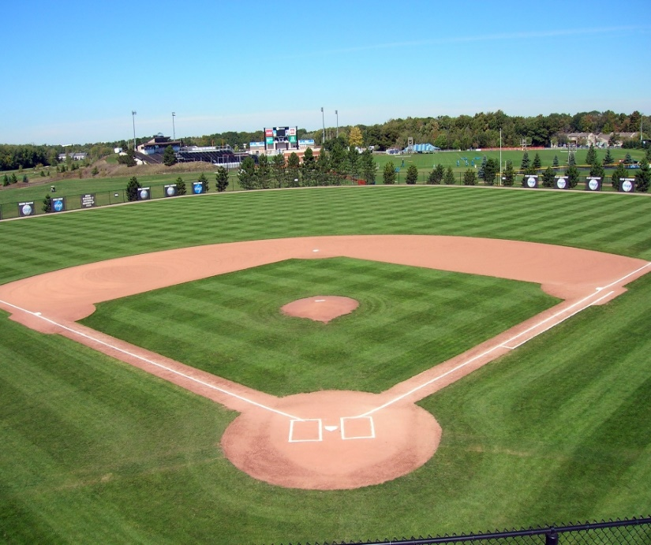

Baseball Sign up
March 27 & 28 at the Pool
4:30pm-6:00pm
Boys and Girls ages 4 thru 16 (must be 4 years old by May 1st)

